Amazon Web Services
SNS
AWS Simple Notification Service (SNS) is a fully managed messaging service that allows you to send notifications automatically to different types of subscribers.
Screenshot 1 – SNS Topic Creation
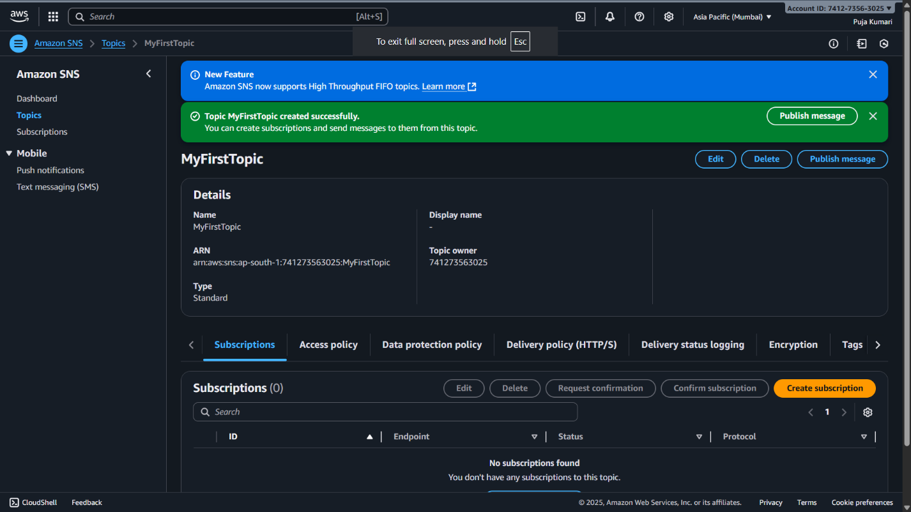
Explaination:
- Opened AWS SNS → clicked Create Topic
- Selected Standard topic type and named it MyFirstTopic
- AWS created the topic and showed a success message + Topic ARN
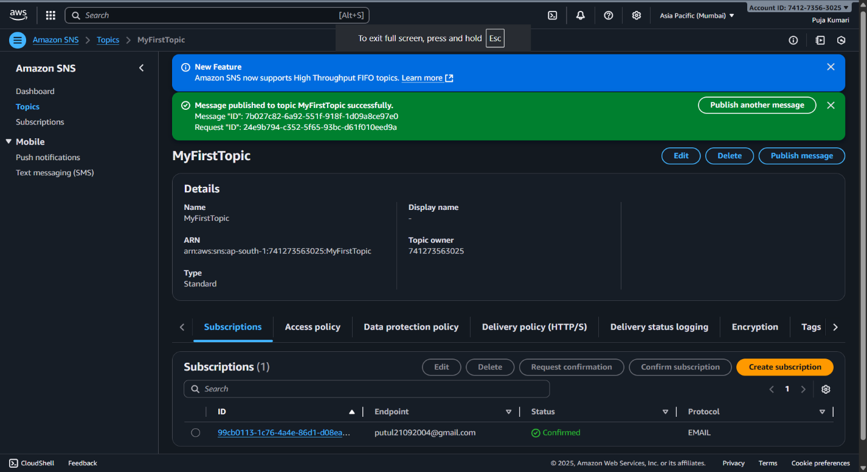
Screenshot 2 – Creating a Subscription

Explaination:
- Added an email subscription to the SNS topic
- Status showed Pending confirmation
- AWS sent a confirmation email to activate the subscription
Screenshot 3 – Short Points
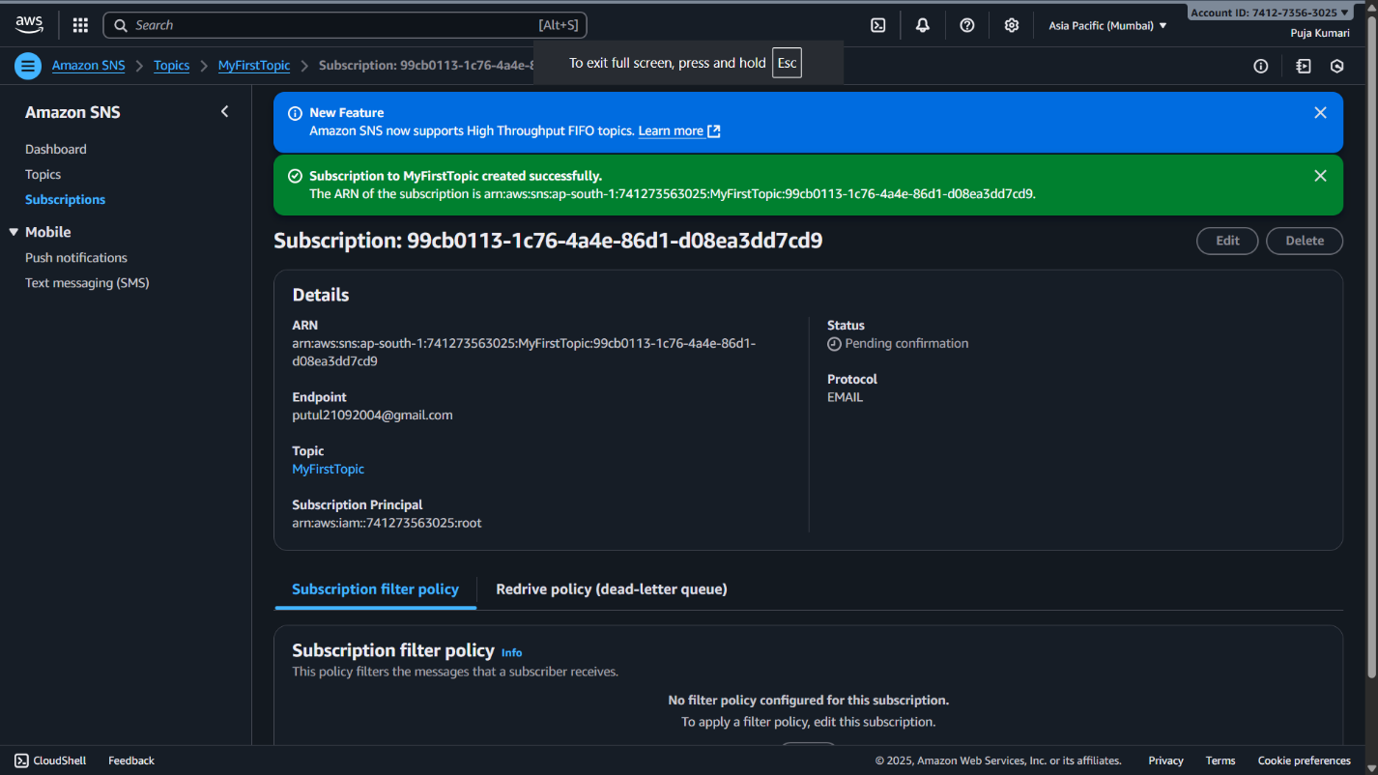
Explaination:
- Subscription status changed to Confirmed after email approval
- Published a test message to the topic
- AWS displayed a success message with Message ID showing it was delivered

